***M*ukan Yerbolat id:210103036  
Sultanov Yerkanat id:210103112**

**Turganbekov Asylkhan id:210103295**

**Melis Tileuli id:210107181**

**U-Point (e-commerce)**

INTRODUCTION

The ***U-Point*** is like an I-Point, but little-bit worse. We sell cheap gadgets from China. To do this, we have developed a **database system** to successfully earn and become super rich.

ENTITY RELATIONSHIP DIAGRAM

1. Customer: This table contains information about customers, including their names, email addresses, phone numbers, and address IDs.

2. Cart: This table stores the details of a customer's shopping cart, including the total price of the items.

3. Cart_Item: This table contains the individual items in a customer's shopping cart, including the product ID and quantity.

4. Orders: This table contains information about customer orders, including the order date, total price, and address ID.

5. Order_Item: This table contains the individual items in a customer's order, including the product ID and quantity.

6. Billing_INFO: This table stores billing information for customer orders, including the bill date and credit card number.

7. Credit_INFO: This table contains information about credit cards used for billing, including the card number and CVV.

8. Product: This table contains information about products for sale, including the product name, description, price, and subcategory ID.

9. SubCategory: This table stores the subcategories to which products belong, including the subcategory name and category ID.

10. Category: This table stores the categories to which subcategories belong, including the category name.

11. Feedback: This table contains feedback from customers about specific products, including the feedback text and product ID.

12. Addresses: This table stores the addresses of customers, including the postal code, country, city, and home number.

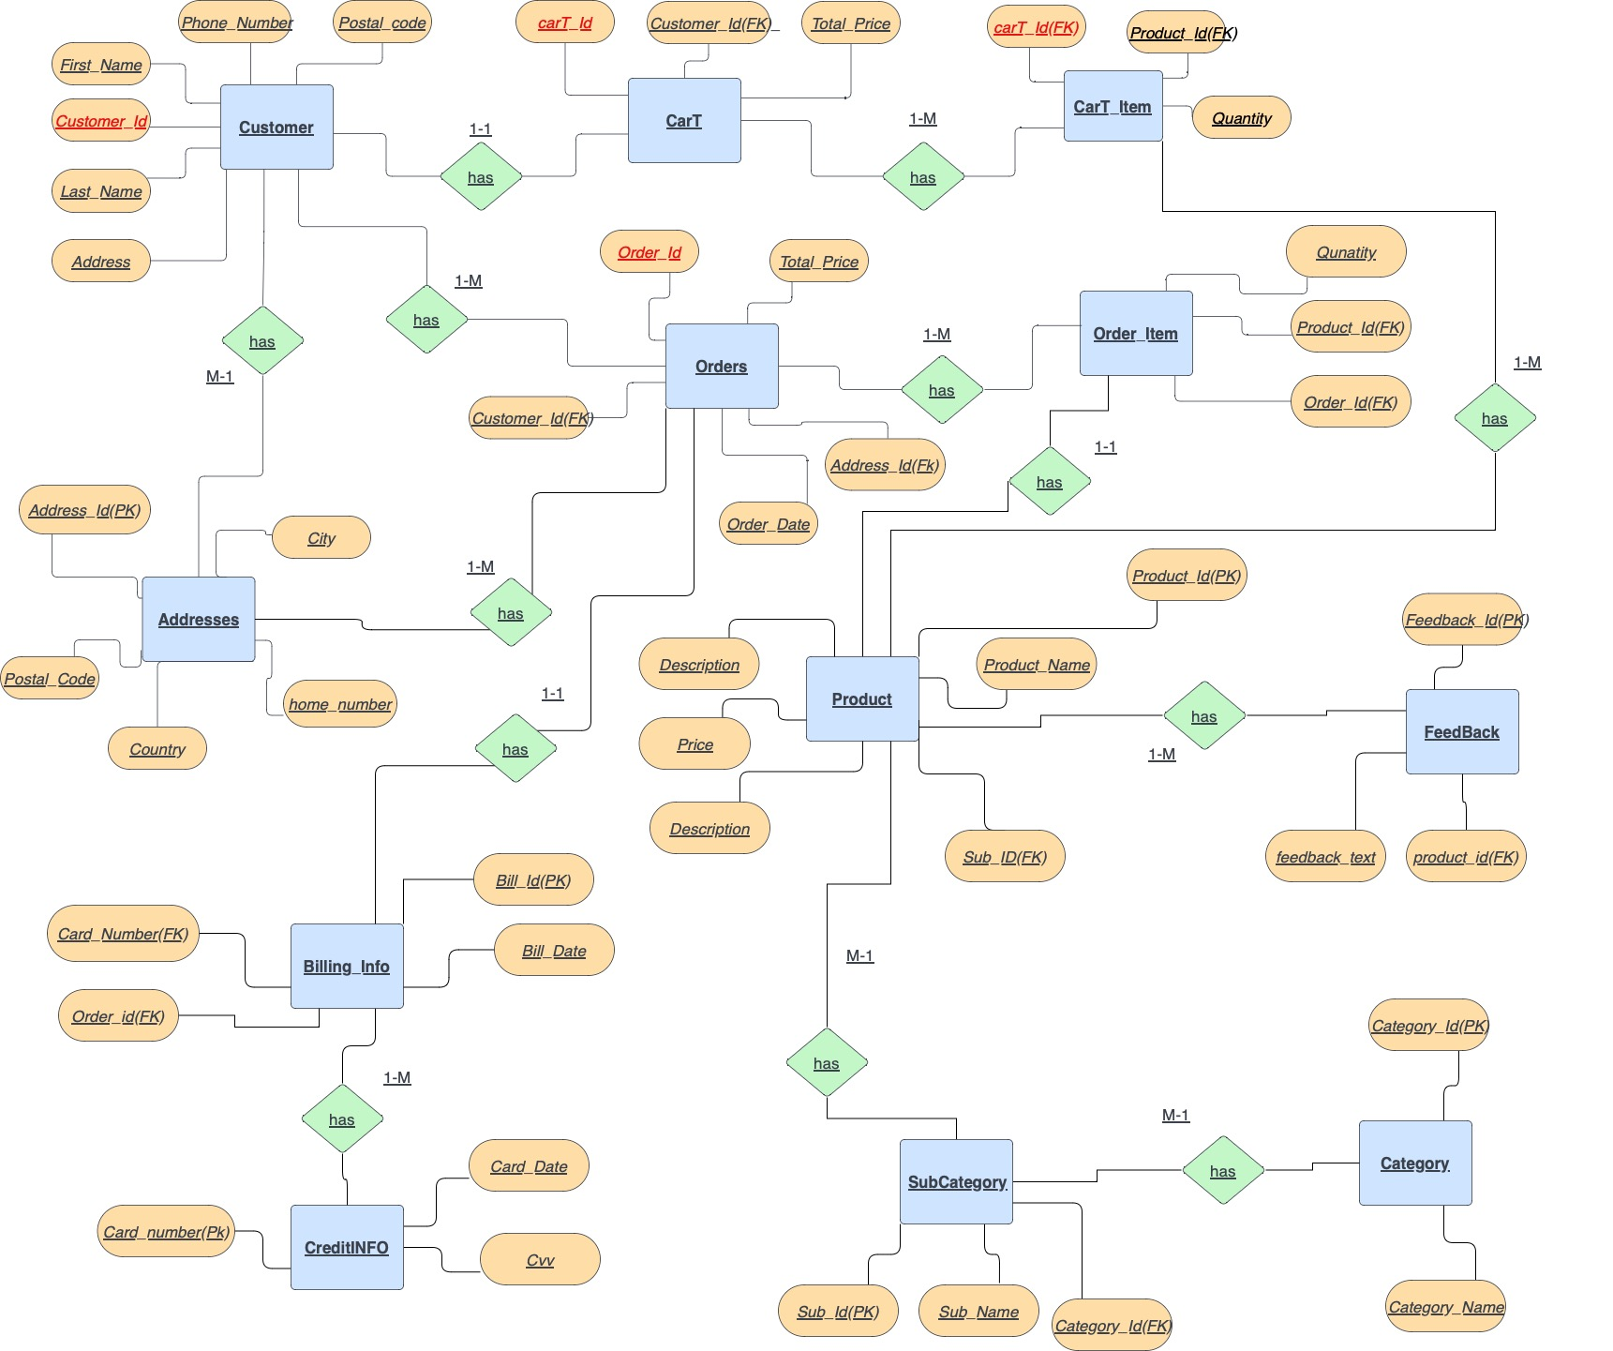

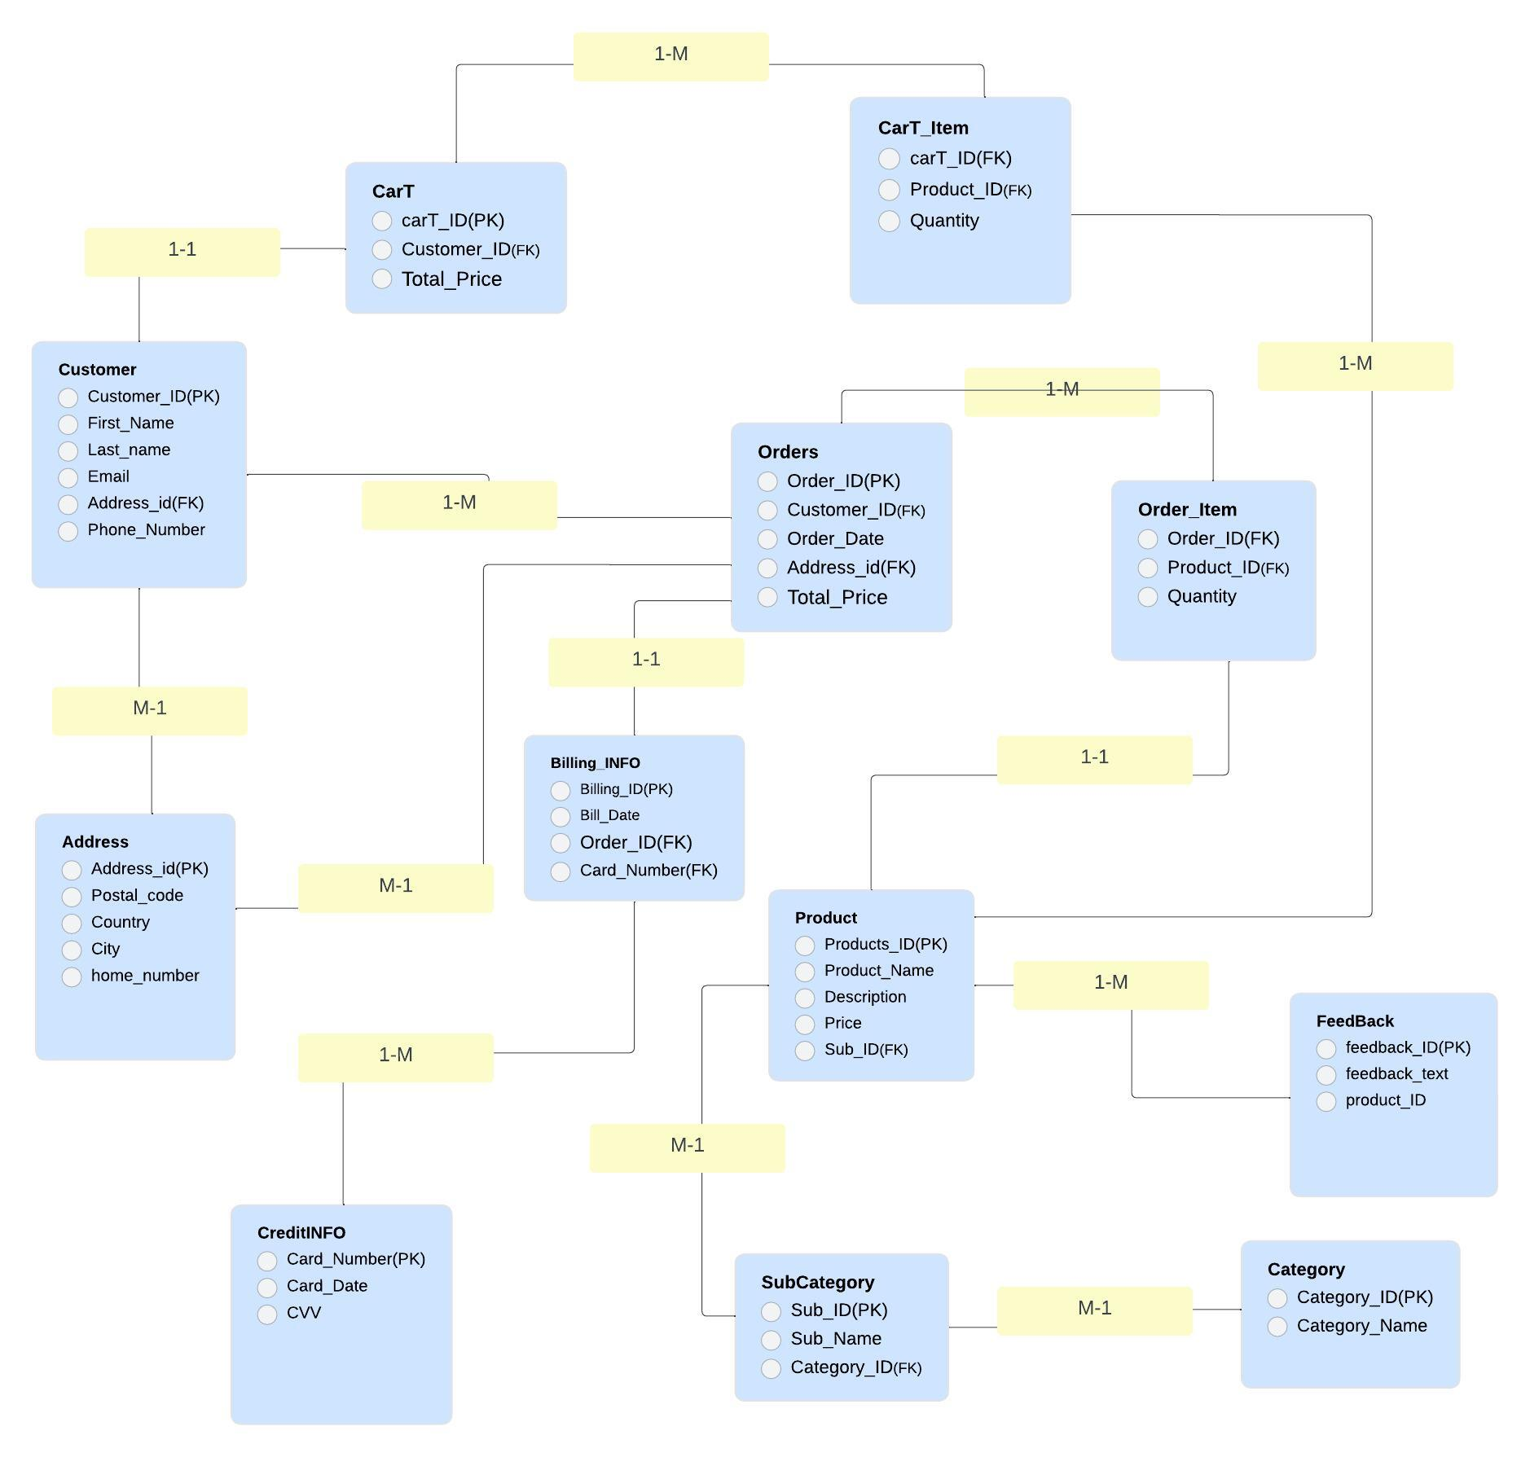

NORMAL FORMS

*Customer Table*

Customer_ID is a primary key, and thus satisfies 1NF and 2NF.

First_Name and Last_Name are atomic, and thus satisfy 1NF.

Email is atomic and unique, and thus satisfies 2NF.

Address_id is a foreign key that references Addresses, and thus satisfies 2NF.

Phone_Number is atomic, and thus satisfies 1NF.

The Customer table appears to be in 3NF.

*CartT Table*

CartT_ID is a primary key, and thus satisfies 1NF and 2NF.

Customer_ID is a foreign key that references Customer, and thus satisfies 2NF.

Total_Price is atomic, and thus satisfies 1NF.

The CartT table appears to be in 3NF.

*Cart_Item Table*

id is a primary key, and thus satisfies 1NF and 2NF.

CartT_ID is a foreign key that references CartT, and thus satisfies 2NF.

Product_ID is a foreign key that references Product, and thus satisfies 2NF.

Quantity is atomic, and thus satisfies 1NF.

The Cart_Item table appears to be in 3NF.

*Orders Table*

Order_ID is a primary key, and thus satisfies 1NF and 2NF.

Customer_ID is a foreign key that references Customer, and thus satisfies 2NF.

Order_Date is atomic, and thus satisfies 1NF.

Total_Price is atomic, and thus satisfies 1NF.

Address_id is a foreign key that references Addresses, and thus satisfies 2NF.

The Orders table appears to be in 3NF.

*Order_Item Table*

id is a primary key, and thus satisfies 1NF and 2NF.

Order_ID is a foreign key that references Orders, and thus satisfies 2NF.

Product_ID is a foreign key that references Product, and thus satisfies 2NF.

Quantity is atomic, and thus satisfies 1NF.

The Order_Item table appears to be in 3NF.

*Billing_Info Table*

Billing_ID is a primary key, and thus satisfies 1NF and 2NF.

Bill_Date is atomic, and thus satisfies 1NF.

Order_ID is a foreign key that references Orders, and thus satisfies 2NF.

Credit_Number is a foreign key that references Credit_Info, and thus satisfies 2NF.

The Billing_Info table appears to be in 3NF.

*Credit_Info Table*

Card_Number is a primary key, and thus satisfies 1NF and 2NF.

Card_Date is atomic, and thus satisfies 1NF.

CVV is atomic, and thus satisfies 1NF.

The Credit_Info table appears to be in 3NF.

*Product Table*

Products_ID is a primary key, and thus satisfies 1NF and 2NF.

Product_Name is atomic, and thus satisfies 1NF.

Description is atomic, and thus satisfies 1NF.

Price is atomic, and thus satisfies 1NF.

Sub_ID is a foreign key referencing the primary key of SubCategory table, and thus satisfies 2NF and 3NF.

The Product table appears to be in 3NF.

*Subcategory Table*

Sub_ID is a primary key, and thus satisfies 1NF and 2NF.

Sub_Name is atomic, and thus satisfies 1NF.

Category_ID is a foreign key referencing the primary key of Category table, and thus satisfies 2NF and 3NF.

The Subcategory table appears to be in 3NF.

*Category Table*

Category_ID is a primary key, and thus satisfies 1NF and 2NF.

Category_Name is atomic, and thus satisfies 1NF.

The Category table appears to be in 3NF.

*Feedback Table*

Feedback_ID is a primary key, and thus satisfies 1NF and 2NF.

Feedback_Text is atomic, and thus satisfies 1NF.

Product_ID is a foreign key referencing the primary key of Product table, and thus satisfies 2NF and 3NF.

The Feedback table appears to be in 3NF.

*Addresses Table*

Address_ID is a primary key, and thus satisfies 1NF and 2NF.

Postal_Code is atomic, and thus satisfies 1NF.

Country is atomic, and thus satisfies 1NF.

City is atomic, and thus satisfies 1NF.

Home_Number is atomic, and thus satisfies 1NF.

The Addresses table appears to be in 3NF.

CODE PART

1. Procedure which does group by information

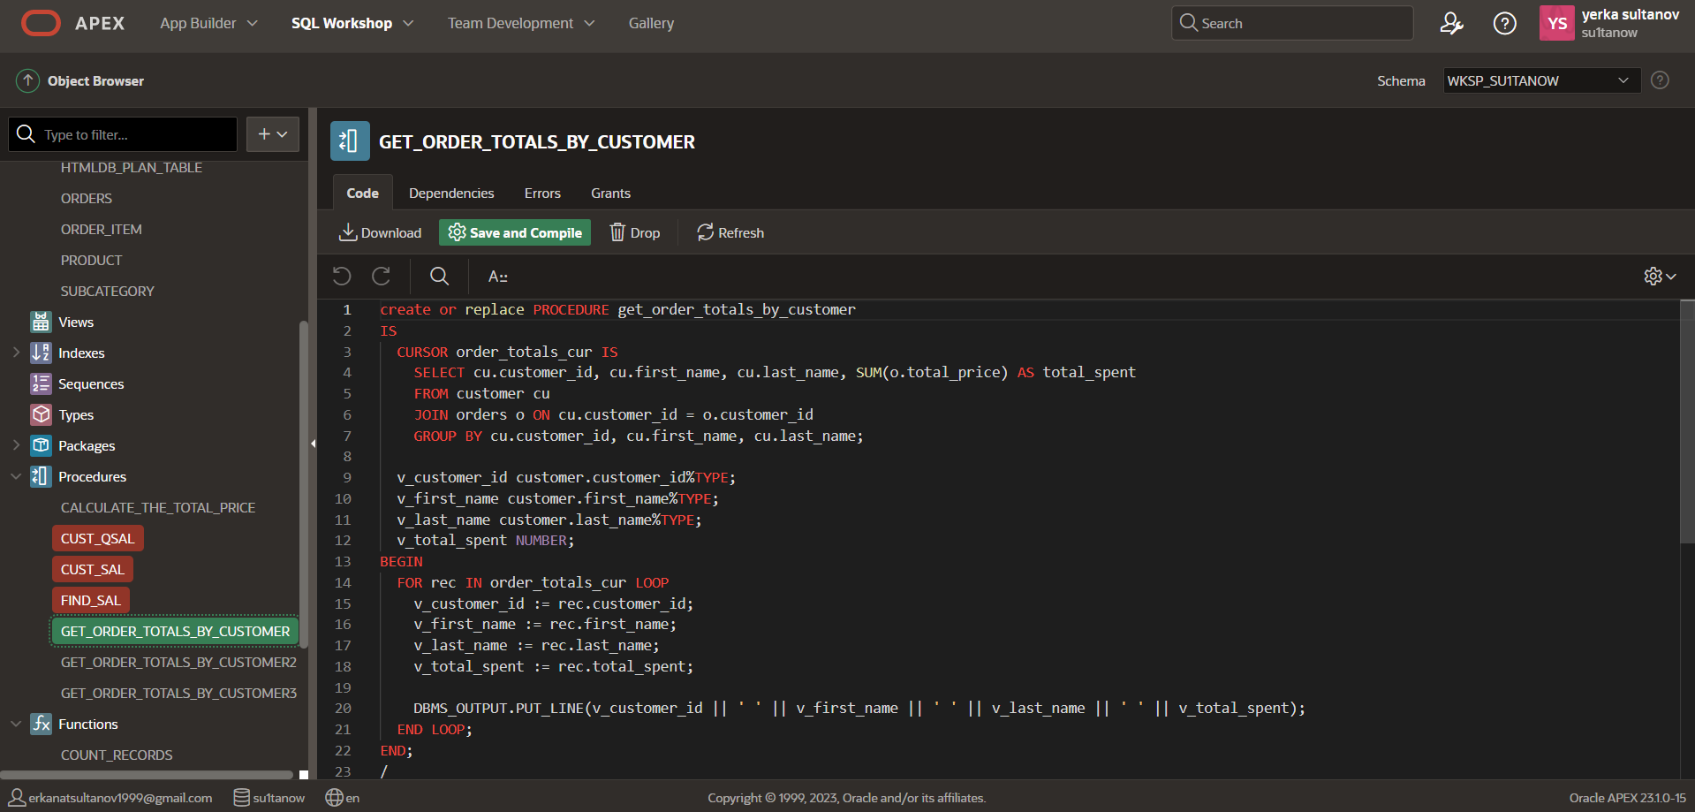

for checking:   
 BEGIN

get_order_totals_by_customer;

END;

1. Function which counts the number of records

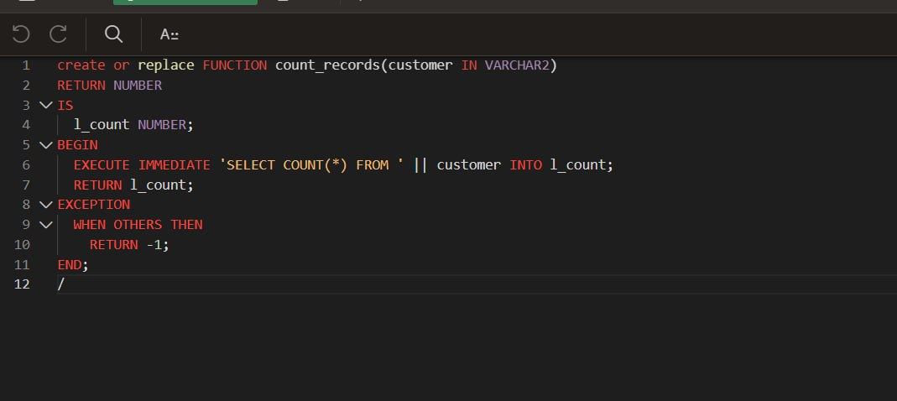

running:

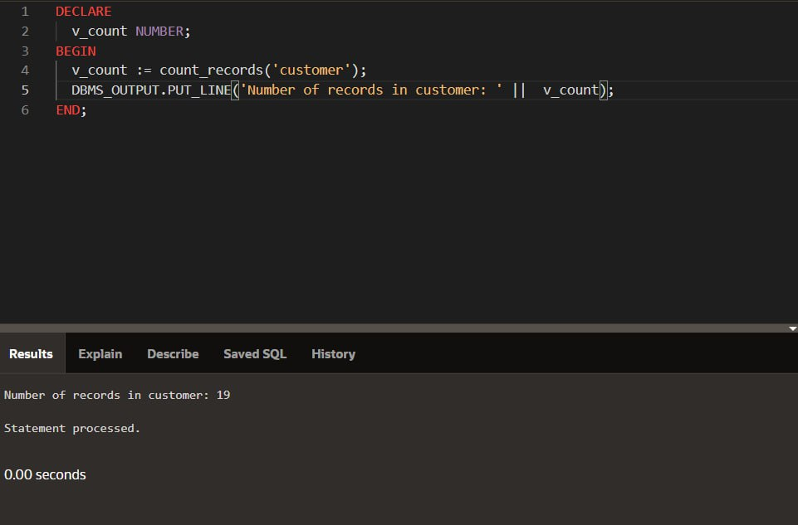

1. Procedure which uses SQL%ROWCOUNT to determine the number of rows affected

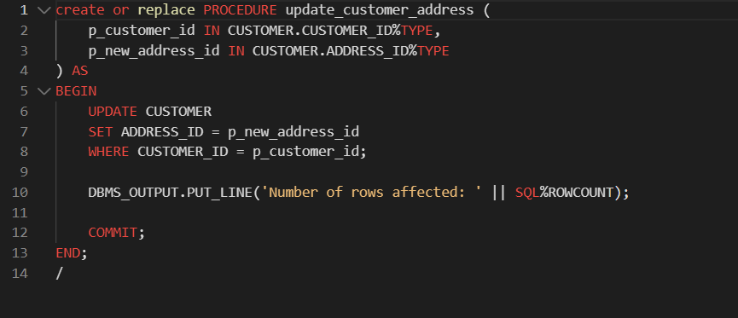

running : 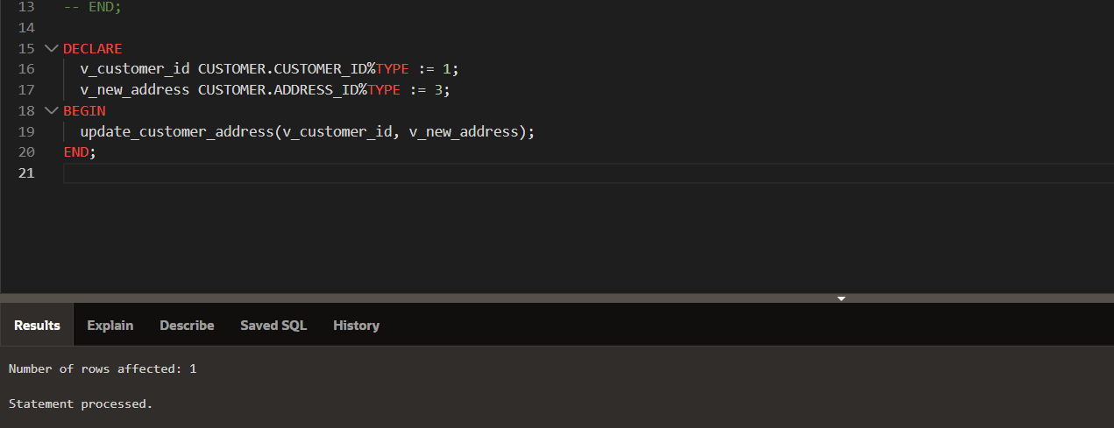

1. Add user-defined exception which disallows to enter title of item (e.g. book) to be less than 5 characters

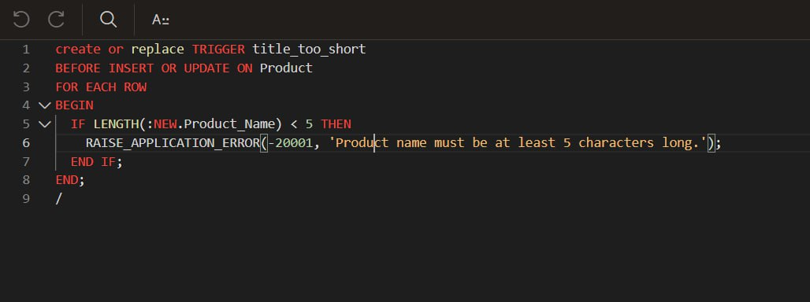

1. Create a trigger before insert on any entity which will show the current number of rows in the table

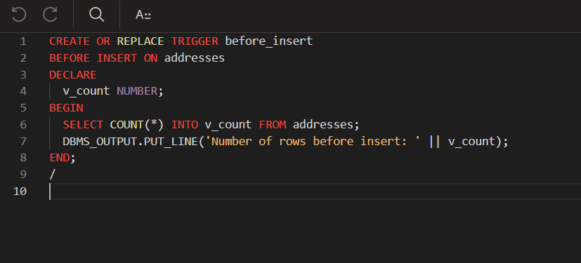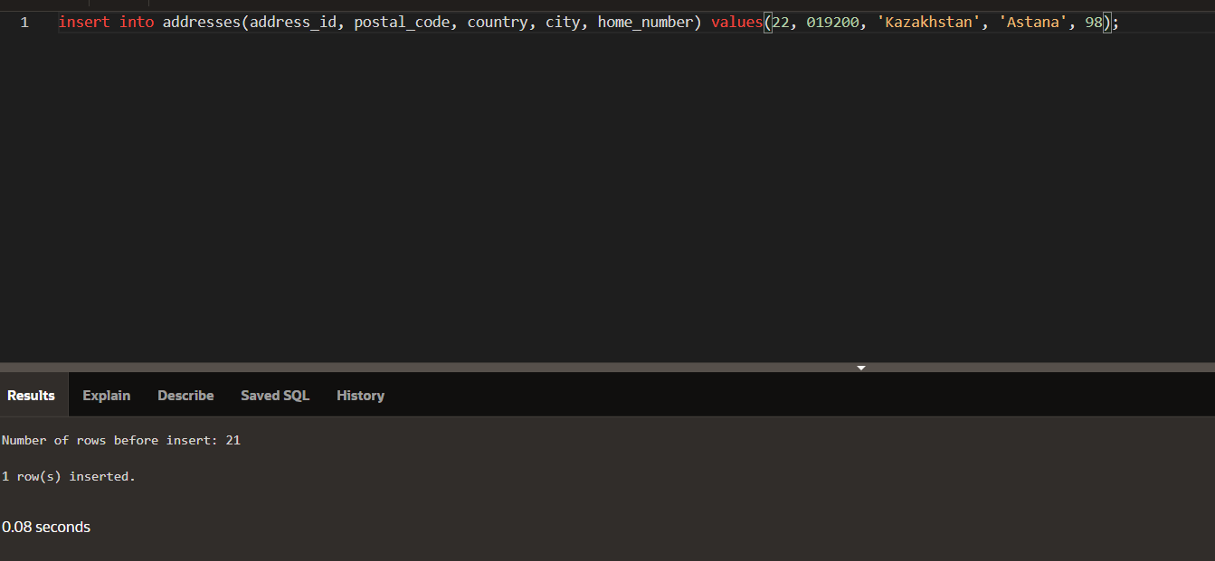

1. Calculate revenue,in some interval

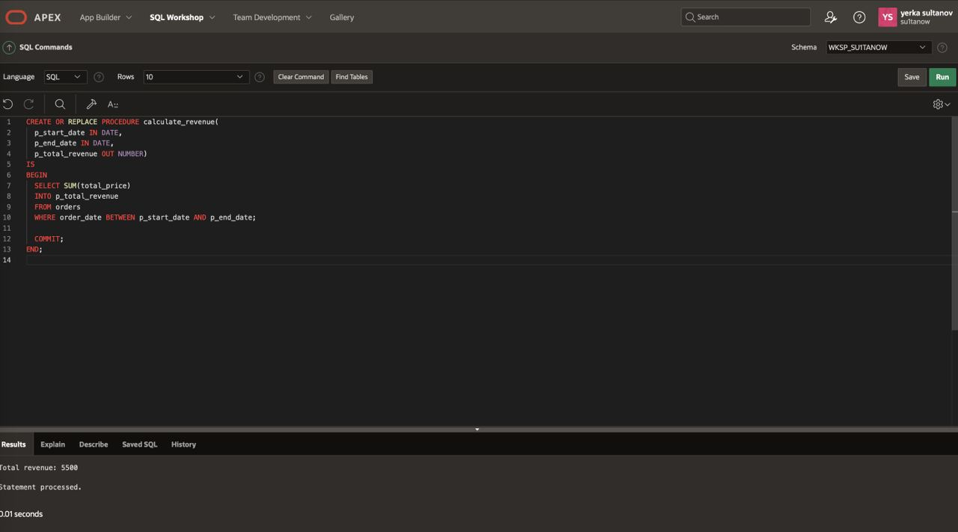

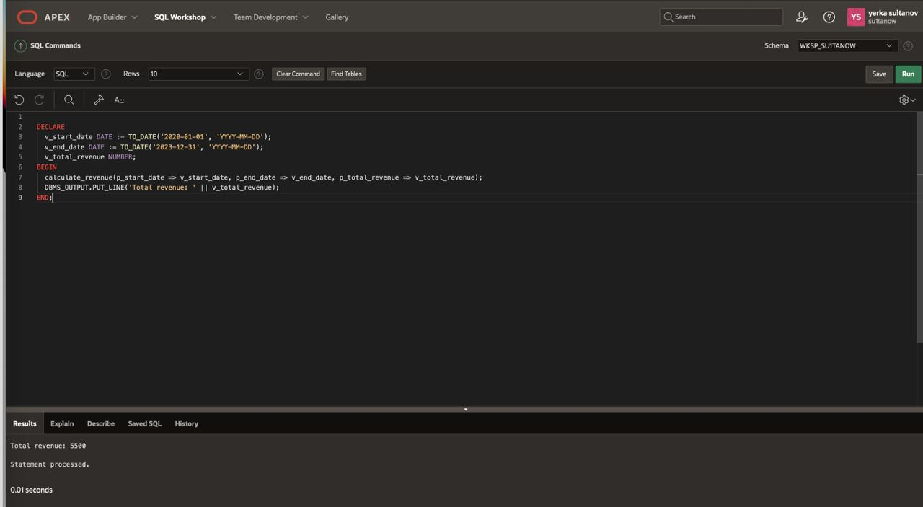

1. Procedure to get customer details by customer ID:  
   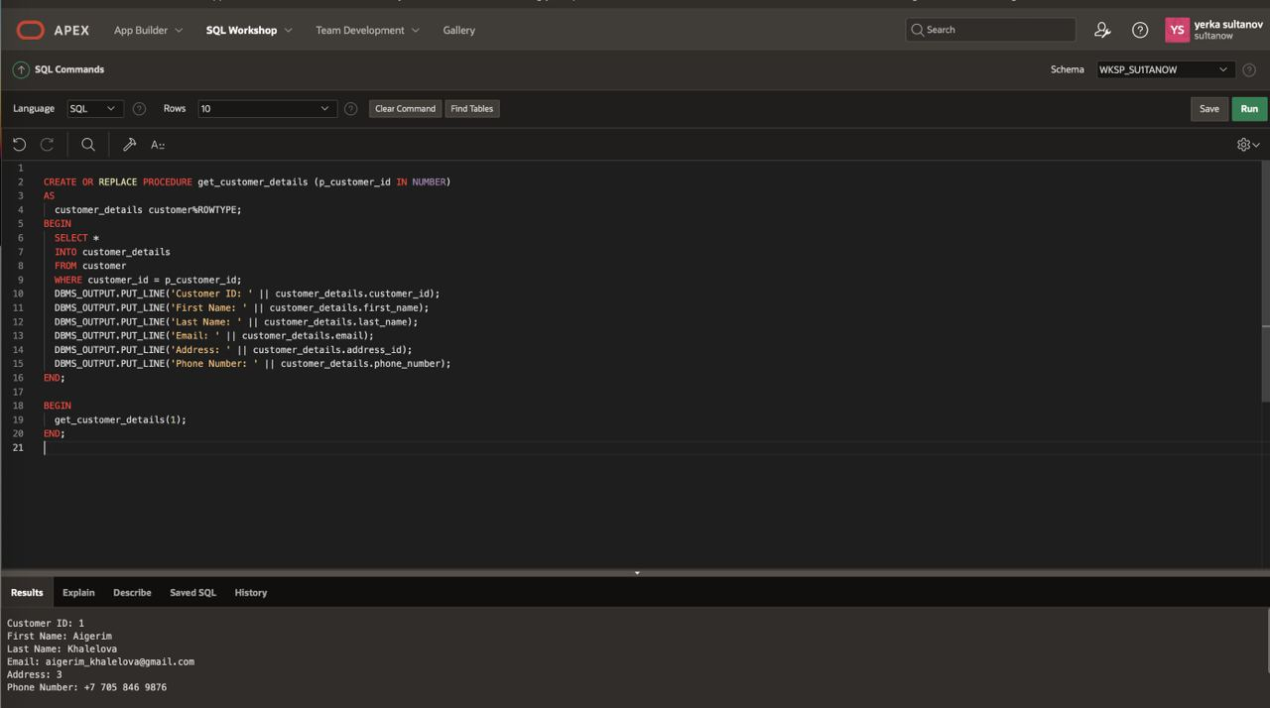
2. Procedure to insert a new feedback for a product:  
   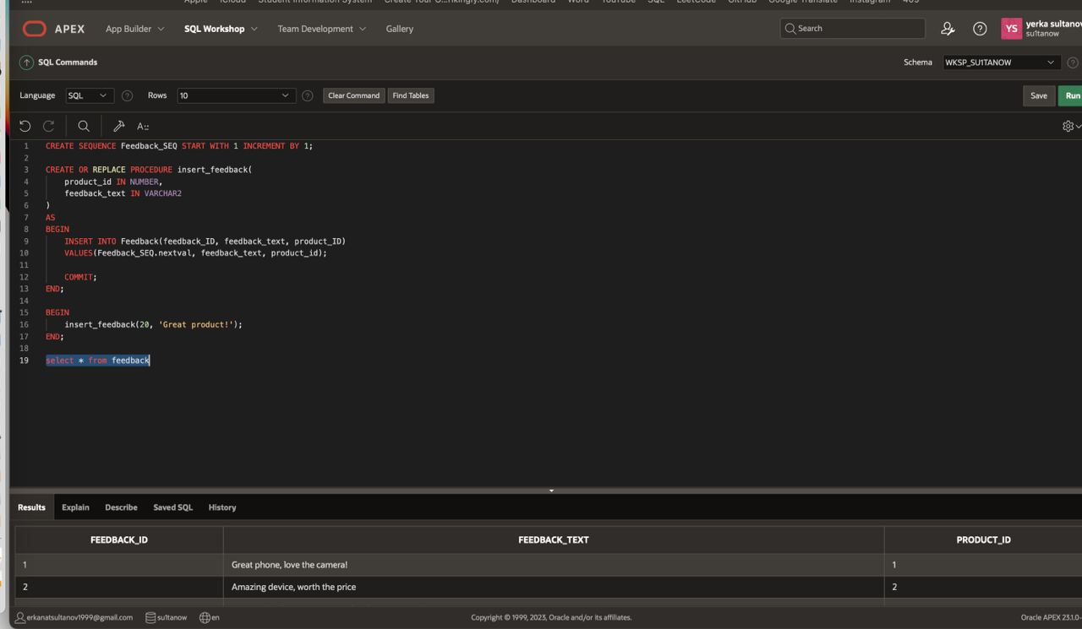
3. trigger that limit orders for one customer

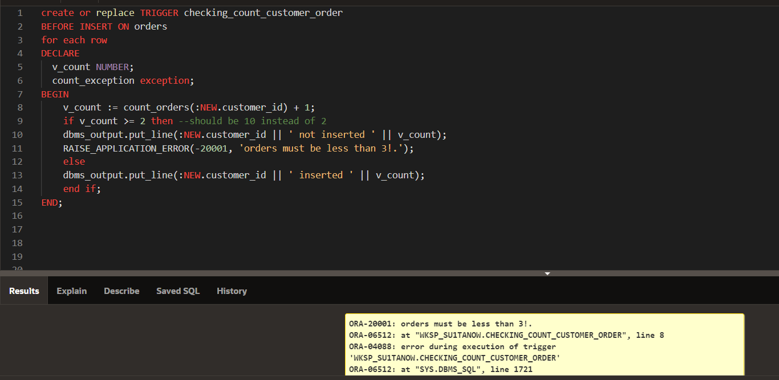

insert into orders (order_id, customer_id, order_date, total_price, address_id) values (13, 2, TO_DATE('04/01/2020', 'MM/DD/YYYY'), 100, 1);

1. update cart total price

